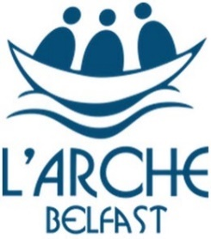

NOT EVERYDAY IS THE SAME
Language Community
Flexibility Culture Team Adventure

WE HAVE OPEN APPLICATIONS FOR 2020

Come to Belfast, Northern Ireland and Become An
Overseas Live-in Volunteer

Requirement: 18 or older
Year-long committement
Involves:
- Creating positive relationships with people with learning disabilities
- Supporting needs, sharing joys and challenges of daily life with core-members
- Will receive hands on training
- Working in a team
- Receive suport and supervision
Rewards:
- Being part of an international community
- Room and board provided
- Experience Belfast
- Practice english skills
- Use your own gifts and skill set
- Personal development to add to your CV
Contact : Volunteer Coordinator
Email volunteers@larchebelfast.org.uk
Phone :+442890641088

Registered with the Charity Commission for Northern Ireland NIC105755

